LAB - 3

***The Unix architecture has 4 layers. These layers are as shown below:***

* **Layer-1:** **Hardware:** It consists of all hardware related information.
* **Layer-2: Kernel:**It interacts with hardware and most of the tasks like memory management, task scheduling, and management are done by the kernel.
* **Layer-3: Shell commands**: Shell is the utility that processes your requests. When you type in a command at the terminal, the shell interprets the command and calls the program that you want. There are various commands like cp, mv, cat, grep, id, wc, nroff, a.out and more.
* **Layer-4: Application Layer:** It is the outermost layer that executes the given external applications.

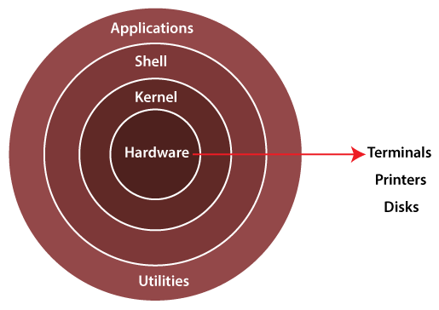

* 1. **Hardware:**Hardware is the simplest and least powerful layer in the Unix Architecture. Hardware is the components that are humanly visible. Whatever hardware is connected to a Unix operating system-based machine, comes in the hardware layer.
  2. **Kernel:** This is the most powerful layer of the Unix architecture. The kernel is responsible for acting as an interface between the user and the hardware for the effective utilization of the hardware. The kernel handles the hardware effectively by using the device drivers. The kernel is also responsible for process management. So, the main 2 features of the kernel are process management and file management.

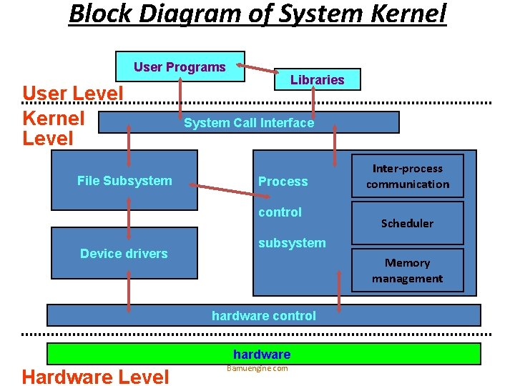

* **Process Management:**The processes that execute within the operating system require a lot of management in terms of memory being allocated to them, the resource allocation to the process, process synchronization, etc. All this is done by the Kernel in Unix OS. This is done using various Operating System Techniques like paging, framing, virtual memory, swapping, context-switching, etc.
* **File Management:**File management involves managing the data stored in the files. This also includes the transmission of data stored in these files to the processes as and when they request it.
  1. **Shell:**We understood the importance of the kernel and that it handles most of the important and complex tasks of Unix OS. Since the kernel is such an important program of the Unix Operating System, its direct access to the users can be dangerous. Hence, the Shell comes into the picture. Shell is an interpreter program that interprets the commands entered by the user and then sends the requests to the kernel to execute those commands. When the execution of the process is completed, the shell again sends a request to the kernel to display the program/information on the screen to the user. So, Kernel is an interface between the user and the hardware and the Shell is an interface between the user and the Kernel. The shell can be used for opening a file, writing into the files, executing programs, etc. There are 3 types of shells in the Unix Operating system.

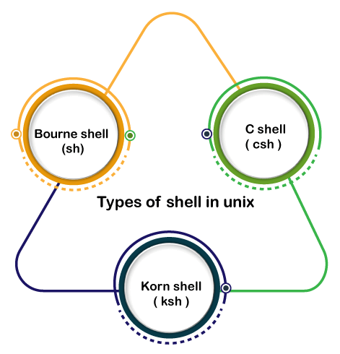

* **Bourne Shell (sh):**It is the most widely available shell on Unix OS devices across the world. This was the first shell available in the Unix OS. It is simply called a shell.
* **C Shell (csh):**The University of California (Berkeley) developed C Shell is another Unix shell that removes some of the obsolete features or problems from the Bourne Shell. So, it enhances the performance of the Bourne Shell.
* **Korn Shell (ksh):**The name of the Korn Shell is based on its creator, David Korn. This shell enhances the C shell further by removing the shortcomings of the C shell and also enhancing the user interaction of the Bourne Shell.
  1. **Applications/Application Programs:**The last layer of the Unix architecture is the Application Program layer. As the name suggests, this outermost layer of Unix Architecture is responsible for executing the application programs.